Christmas 2019
Well it’s that time of year again, the Staff and Clients have been busy making things to sell on our market stall, and as usual we have lots of fun activities and entertainment planned.
We have a selection of Christmas cards for sale in aid of The Hunter Centre. These are on sale at the centre or come and see us at the Christmas market 1st December
Dates for your diary
Thursday 14th November – Public Meeting, Marjorie Gray Hall, 7pm. With refreshments. We will also have a short presentation by a local wellbeing advisor, Claudia Vargas.
Sunday 1st December – Haslemere Christmas Market, 10am – 5pm. We will be in our usual spot in the Museum. Unwanted gifts, homemade cakes etc…. would be appreciated.
Wednesday 4th December - A Christmas celebration. St Bartholomew’s Church, Derby Road. Haslemere. At 7pm. £12.50 a ticket. With mulled wine and mince pies in The Link afterwards. For more information or to buy tickets please contact Elaine Clement 01428 654710 manager@thehuntercentre.co.uk
Thursday 5th December – 11am - Mary Gorniack – Flautist

Wednesday 11th December – 11am – Sing along with Claire and Nev.

Wednesday 11th December – 6.30pm - Volunteers Christmas Party

Thursday 12th December – 2pm - St Bartholomew’s School Children
Everyone is welcome to join us whether or not the person you are caring for attends on these days.

Monday 16th December – 12pm – Carers and Clients Christmas Party. Christmas lunch at 12.30, then at 2.30 Natasha will be entertaining us. There will also be a raffle on the day. If you and the person you are caring for would like to come and have some fun, please RSVP to Denise on 01428 654710 or deputy@thehuntercentre.co.uk by Monday 9th December.
Christmas and New year opening times
Monday 23rd – Open as usual
Tuesday 24th – Open 10am – 3.30pm
Wednesday 25th – Closed
Thursday 26th – Closed
Friday 27th – Closed
Monday 30th – Open as Usual
Tuesday 31st - Closed
Wednesday 1st January 2020 – Closed
Thursday 2nd – Open as usual
Friday 3rd – Open as usual
**********************
This Photo by Unknown Author is licensed under CC BY-ND

Karen, Our Chiropodist, will next be visiting Wednesday 27th November 2019.
£20 per person. Payable on the day.
If you would like your loved one to be seen by Karen, please let Denise know.
deputy@thehuntercentre.co.uk

******************

The next dementia carers café will be held on Tuesday 26th November 10.30am – 12.30pm.

December – No group.

*****************
Amazon Smile

For those who shop on line, Amazon now have a site that donates to your chosen charity. All you need to do is register with AMAZON SMILE and select The Hunter Centre.
They will donate 0.5% to the charity when you shop on that site on selected items

For Sale by donation
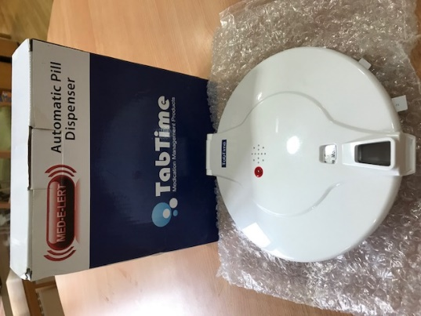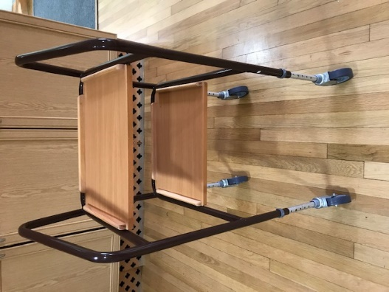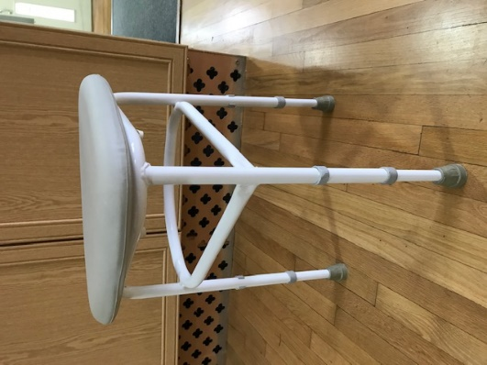
Automatic pill dispenser Indoor Trolly Bathing Stool

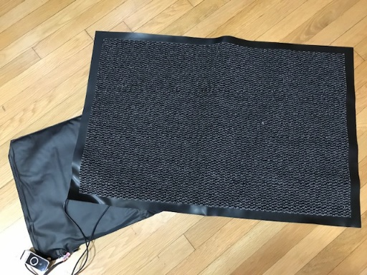
Sensor Mat
Can be used either in the bedroom or by the front door

For more information, please contact Elaine Clement, Operations Manager
01428 654710
manager@thehuntercentre.co.uk

www.thehuntercentre.co.uk

The Hunter Centre is a charity registered in England with Charity number 1173587 and its address for service is Unit 7 Index House Midhurst Road Liphook Hampshire GU30 7TN

