This Photo by Unknown Author is licensed under CC BY-SA
Summer 2019
Happy 2nd Birthday to everyone at The Hunter Centre
This Photo by Unknown Author is licensed under CC BY-SA
The last 2 years have gone so quickly!!!
The Trustees, Staff, Volunteers and Clients can’t thank you all enough for your continued support and to the ladies from Haslemere WI for our weekly supply of delicious homemade cakes.
We would also like to say ‘Hello’ to our 3 new members of staff, Tina and Bev who are working on Thursdays and Gilly who helps to cover annual leave.

We’ve had a busy spring and summer, loads of activities and visitors.
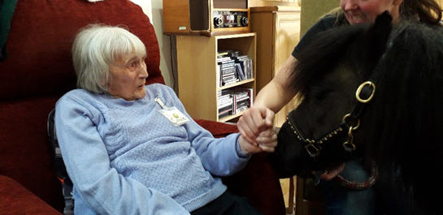
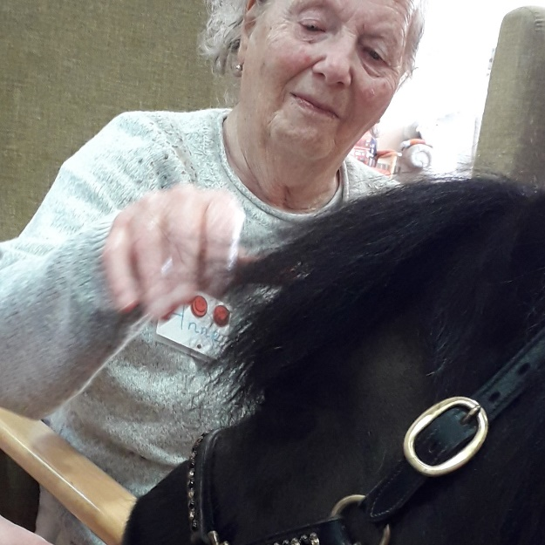
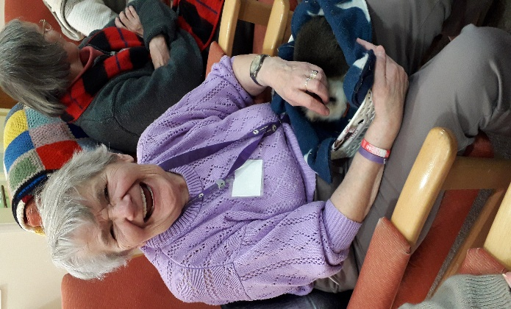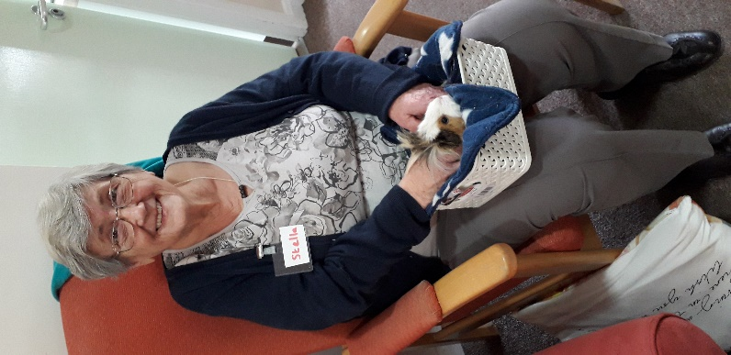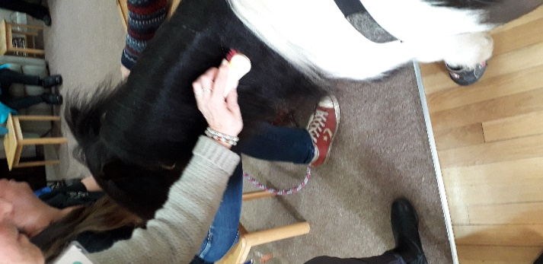
PONY PALS

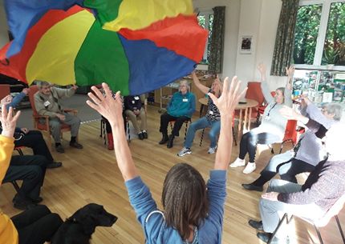
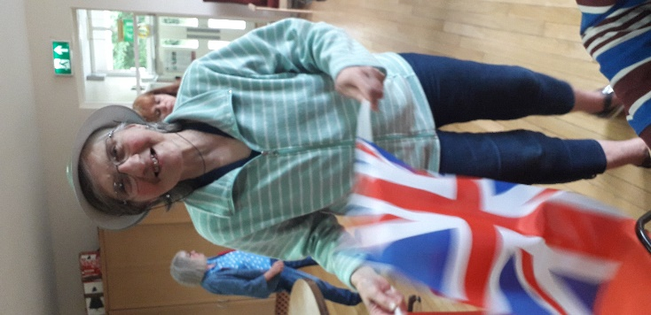
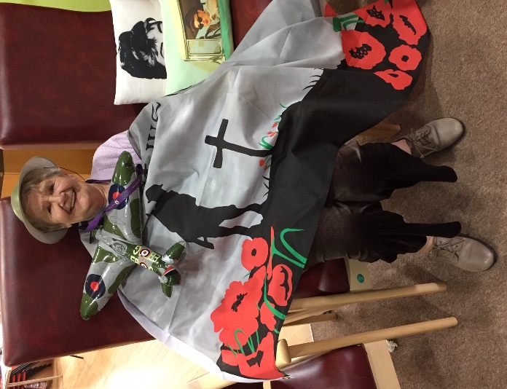
Celebrating 75th Anniversary of the D Day landings
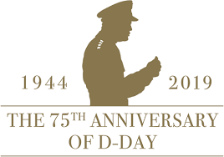

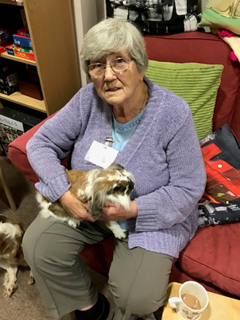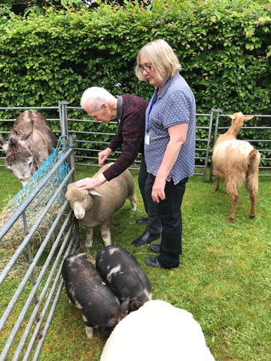
Mill Cottage Farm
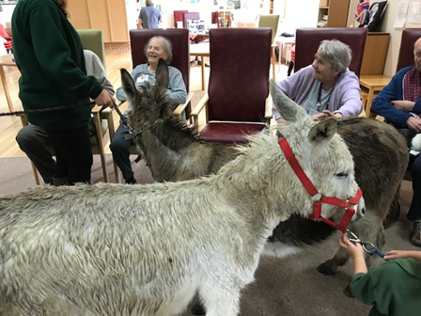
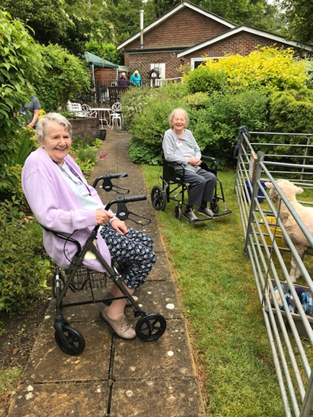

Fundraising.

Saturday 27th April – The Hunter Centre Annual Quiz.
A big Thank You to Charlotte and David Drew who once again organised a fabulous evening. They raised an amazing £620.90.
Congratulations to Amanda and Friends, The winners for 2019!

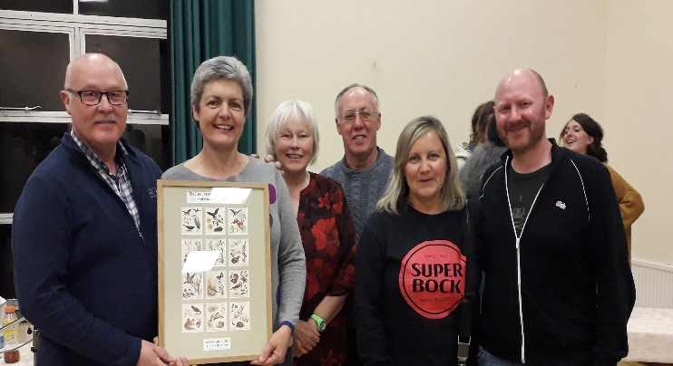

**************
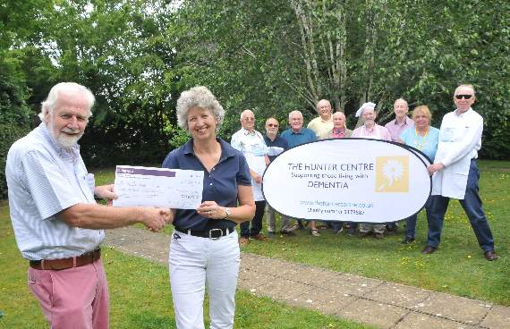
The Hunter Centre funds were recently boosted by The Towns U3A cooks, The Gourmet Geezers. Ken Griffiths (Head Chef) presented a cheque for £ 3045.64. The Money was raised from sales of their very own cookbook and from a Gala Dinner held in May.
********************

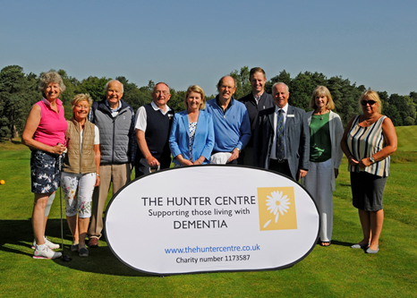

On Thursday, 27th June, nearly 100 golfers enjoyed 18 holes in the glorious sunshine at Liphook Golf Club's Captains Charity Day.
A silent auction was held throughout the day along with a £10 draw.....raising an amazing £9,500 For The Hunter Centre, Liphook Captains Charity of the year.
Thank you to Mike Kendall and Siobhan Dawson, this year’s captains, for choosing to support us.
There is still availability at Worplesdon Golf Club’s Charity day, 24th September. In aid of The Hunter Centre.
For more information, please contact Anne Downing on 07786 163738
Or email chairman@thehuntercentre.co.uk

*****************
This Photo by Unknown Author is licensed under CC BY-ND

Karen, Our Chiropodist, will next be visiting Wednesday 24th July 2019.
£20 per person. Payable on the day.
If you would like your loved one to be seen by Karen, please let Denise know.
deputy@thehuntercentre.co.uk
******************
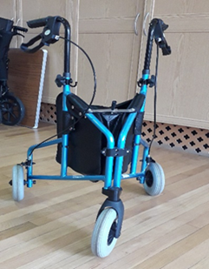
FOR SALE
3-wheel Rollator
£10.00

The next dementia carers café will be held on Tuesday 23rd July 10.30am – 12.30pm.
Penny Giles, Dementia Navigator from Alzheimer’s Society will be here to give advice and support.
August – No group.
September – Tuesday 24th. Sally Cowper from Waverley Citizens Advice will be here for advice on benefits and how to apply for a ‘Blue Badge’.
The government now recognise ‘invisible disabilities’
*****************

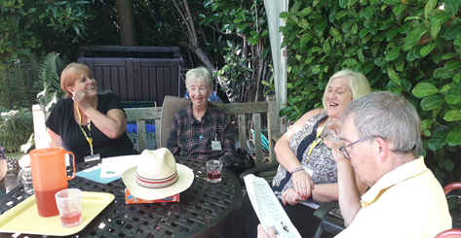
Just enjoying the sunshine….

The Day Centre will be closed on Monday 26th August , Bank Holiday.

For more information, please contact Elaine Clement, Operations Manager
01428 654710
manager@thehuntercentre.co.uk

www.thehuntercentre.co.uk

The Hunter Centre is a charity registered in England with Charity number 1173587 and its address for service is Unit 7 Index House Midhurst Road Liphook Hampshire GU30 7TN

